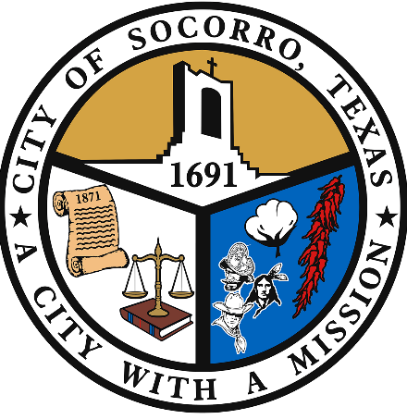
PUBLIC NOTICE:

CITY OF SOCORRO
ADMINISTRATION
(915) 858-2915
124 S. HORIZON BLVD.
SOCORRO, TX 79927

MAYOR:
ELIA GARCIA

REPRESENTATIVE AT LARGE:
RENE RODRIGUEZ

DISTRICT 1 REPRESENTATIVE and MAYOR PRO TEM:
CESAR NEVAREZ

DISTRICT 2 REPRESENTATIVE:
RALPH DURAN

DISTRICT 3 REPRESENTATIVE:
VICTOR PEREZ

DISTRICT 4 REPRESENTATIVE: YVONNE COLON- VILLALOBOS

CITY MANAGER:
ADRIANA RODARTE
City Lobbies Are Closed to the Public

Effective 5 PM MST Monday November 2, 2020, the City of Socorro will be closing their offices to the public to fight the spread of COVID-19. Essential City services will continue to be offered during this time. Should you need assistance please contact us Monday through Friday from 8 AM – 5 PM by phone or visit our website http://ci.socorro.tx.us/ for more information:

Vendors & Postal Courier please contact us for assistance.

  - Administration - (915) 858-2915- 124 S. Horizon Blvd
  - Municipal Court - (915) 872-8574- 860 N. Rio Vista Rd
  - Planning & Zoning - (915) 872-8531- 860 N. Rio Vista Rd.
  - Police- (915) 858-6983- 670Poona Rd.
  - Parks & Public Works-(915) 858-1114 – 241 Old. Hueco Tanks Rd.
  - Recreation - (915) 860-8615- 901 N. Rio Vista Rd.

Lastly the City would like to remind everyone to stay safe by practicing social distancing, proper hygiene, frequent hand washing, use of hand sanitizer, and always wear a face covering while out in public.
###

